2023 Youth and Young Adult Art Contest:
Together on the Journey of Hope
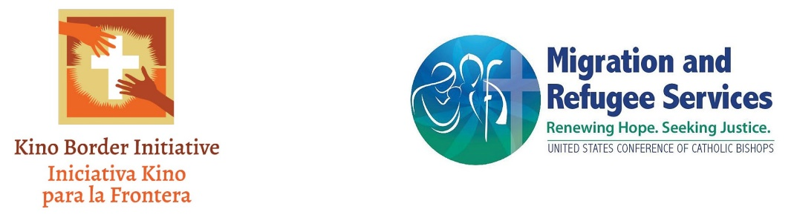

About the Contest:
In celebration of the 20th Anniversary of the pastoral letter Strangers No Longer: Together on the Journey of Hope, issued by the Catholic bishops of Mexico, the United States Conference of Catholic Bishops/Migration and Refugee Services (USCCB/MRS) and Kino Border Initiative (KBI) are sponsoring a migration themed youth and young adult art contest that highlights the subtitle of the letter, which reads “Together on the Journey of Hope.”
Young artists are invited to imagine what this “journey of hope” looks like or represent the ways people in migration walk together on the journey, with their families, with others they meet along the way, with communities in the US who receive and accompany them, with advocates who seek more dignified migration alongside them. Entries could also paint a picture of the artist’s vision for what they hope the migration journey could look like in the future: what does it look like to, as the pastoral letter states, “help newcomers integrate in ways that are respectful, that celebrate their cultures, and that are responsive to their social needs, leading to a mutual enrichment of the local church?” What images, words or colors represent this “journey of hope?”
General Rules:
- All youth, ages 5- 18, are eligible to participate. Participation will be based on four age categories: 5 – 9, 10 – 13, 14 – 18, and 19-22.
- Participants can submit a piece of art in one of three categories: 1. painting or drawing, 2. Photography, or 3. Poetry. Only one submission allowed in total for each participant.
- Submissions must include an original work of art by the youth/young adult. The entry must be accompanied by a Contest Entry Form signed by the youth’s parent or guardian.
- Posters may include multiple mediums such as crayons, markers, paint, pastels, etc.
- Each entry must be submitted electronically to ArtContest@usccb.org.
- Use of any inappropriate image or language will automatically disqualify the entry.
- Entry to this contest results in the automatic submission to the rules and decisions of the USCCB/MRS judges. The copyright and all other rights in and to all entries and submissions of art and all derivative works thereof will belong solely and exclusively to USCCB/MRS.
- Artwork may be used in USCCB/MRS promotions, publications, or exhibitions, or in any other manner in USCCB’s sole and exclusive discretion.
Deadline: The deadline for the submission of entries to USCCB/MRS is May 19, 2023. Entries received after this date will not be eligible.
Prizes: One winner in each age group and category will be selected and receive a $40.00 Visa Gift Card. All art submitted may be used in future USCCB/MRS publications and events.

Permission to participate and Parental Consent Form

We request that you complete this form to confirm that you are authorizing your entry into the Competition on behalf of yourself or your minor child. The Rules can be found at https://www.usccb.org/committees/migration/MRSart. Please read the information contained in the Official rules and this Consent Form carefully before you complete it. Please complete and return this form along with the Contest entry.

I, the undersigned, certify that I am either the Contestant; or the parent or legal guardian of the below-mentioned Contestant.

I hereby authorize the entry of the Contestant named below to participate in the Contest.

Full name Contestant: ___________________________________________________________
Name of artwork (“Artwork”): ____________________________________________________
Age: _________________________________________________________________________
Parent’s/Guardian’s full name: ____________________________________________________
Contact email address: __________________________________________________________
Contact phone number: __________________________________________________________

I confirm that by completing this form, I have read, understood and agreed to the rules for the Contest and that the Contestant will abide by the Art Contest Guidelines. I confirm that the information given in this consent form is complete and accurate. I agree and understand that USCCB shall be the sole and exclusive owner of the Artwork and rights, title and interest in and to the Artwork and any derivative works thereof, including but not limited to the copyright, and that USCCB shall own or be licensed to use any materials and/or elements embodied in the Artwork which are not original to Contestant, and which Contestant shall secure rights, permissions or licenses thereof and provide documentation to USCCB upon request. I agree on behalf of myself, the contestant, my heirs, assigns, executors, and personal representatives, to indemnify USCCB, its member bishops, employees, officers, affiliates, representatives, assigns and successors hold harmless and defend the USCCB from any and all liability that may arise in connection from my own/my child’s participation in the USCCB 2023 Youth and Young Adult Art Contest: Together on the Journey of Hope. I agree that that USCCB may use, assign, license or otherwise transfer its rights under this Agreement and that this Agreement shall inure to the benefit of USCCB’s assigns, successors and licensees.

Contestant grants USCCB the exclusive right to use the photography depicting the Contestant for inclusion in written, audio-visual, and digital materials now known or later developed in perpetuity on the subject of and any ancillary use or derivate works and for all promotional, marketing and merchandising purposes. Contestant acknowledges that the depiction of him/her in the Photo may be duplicated and distributed in any and all manner and in any media now known or later developed throughout the world in perpetuity.

Contestant and USCCB have indicated their acceptance of this Agreement by signing below:

______________________________________________________ _________________
Signature of Contestant (if over 18) or Parent or Legal Guardian Date

______________________________________________________ _________________
Todd Scribner, Assistant Director of Education, USCCB Date

